|  |  |
| --- | --- |
|  | **AMERICAN INTERNATIONAL UNIVERSITY-BANGLADESH (AIUB)**  Faculty of Engineering  Department of Electrical and Electronic Engineering |

##### MICROPROCESSOR AND EMBEDDED SYSTEM LAB



**\*Rename your pdf file name as: SL_ID_NAME_SECTION_GR NO_LAB NO**

**\*Report should be handwritten and PDF in format**

**\*Topics to be covered: Title >> Objectives >> Theory & Methodology >> Apparatus >> Results & Simulations >> Discussion & Conclusion >> Reference**

**\*Submit the report before the next lab class in the provided link (check portal notice)**

|  |  |
| --- | --- |
| **SECTION: D** | **SEMESTER: Spring 2022-2023** |
| **GROUP NUMBER: 02** | **DATE OF SUBMISSION: 06/02/2023** |

**\*Follow the upload rules during submission**

|  |  |
| --- | --- |
| **SUBMITTED BY** | |
| **NAME: Kakon, Khairul Islam** | **ID: 20-42438-1** |
| **CLASS SERIAL NUMBER: 36** | **CONTACT: 01923089370** |

|  |
| --- |
| **LAB NO: 01**  **TITLE:** Familiarization with a microcontroller, the study of blink test and implementation of a traffic control system using microcontrollers. |

|  |  |  |  |
| --- | --- | --- | --- |
| **Class SL** | **Group Member’s Name** | **ID** | **Contact Number** |
| 36 | Kakon, Khairul Islam | 20-42438-1 | 01923089370 |
|  |  |  |  |
|  |  |  |  |
|  |  |  |  |
|  |  |  |  |
|  |  |  |  |
|  |  |  |  |
|  |  |  |  |
|  |  |  |  |
|  |  |  |  |

**SUBMITTED TO:**

**SUJAN HOWLADER (ESSAN), ASSISTANT PROFESSOR**

**DEPARTMENT OF EEE, FACULTY OF ENGINEERING**

**Title:** Familiarization with a microcontroller, the study of blink test and implementation of a traffic control system using microcontrollers.

# Objectives:

# The objectives of this experiment are to-

1. Familiarize with the Arduino microcontroller
2. Implement a simple circuit to make LED lights blink using the delay function
3. Implement a simple traffic control system.

**Theory and Methodology**

Arduino is an open-source platform used for creating interactive electronics projects. Arduino consists of both a programmable microcontroller and a piece of software, or IDE (Integrated Development Environment) that runs on your computer, used to write and upload computer code to the microcontroller board. Arduino Uno also doesn’t need a hardware circuit (programmer/ burner) to load a new code into the board. We can easily load a code into the board just using a USB cable and the Arduino IDE (which uses an easier version of C++ to write code).

**Overview of Arduino Board:**

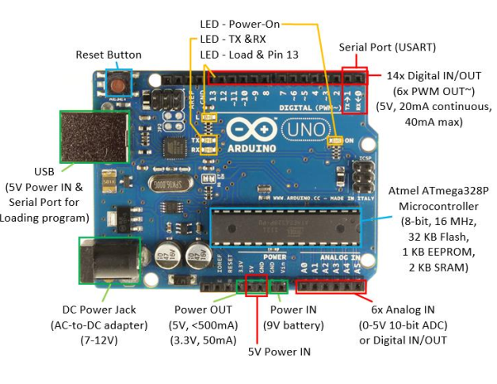

**Arduino Family:**

The Arduino family of boards use processors developed by the Atmel Corporation of San Jose, California. Most of the Arduino designs utilize the 8-bit AVR series of microcontrollers, with the Due being the primary exception with its ARM Cortex-M3 32-bit processor. Arduino makes several different boards, each with different capabilities. In addition, part of being open-source hardware means that others can modify and produce derivatives of Arduino boards that provide even more form factors and functionality.

**Arduino Uno (R3):**

The Arduino Uno R3 is a microcontroller board based on a removable, dual-inline-package (DIP) ATmega328 AVR microcontroller. It has 20 digital input/output pins (of which 6 can be used as PWM outputs and 6 can be used as analog inputs). Programs can be loaded onto it from the easy-to-use Arduino computer program. The Arduino Uno R3 board has six new features: The Arduino Uno R2 has an ATMEGA8U2 USB microcontroller on board while the Arduino Uno R3 development board has an ATMEGA16U2 on it. It's more advanced than R2. The Arduino Uno R3 board adds a diode across the USB ATMEGA reset pin pull-up resistor. The Uno is a great choice for your first Arduino. It's got everything you need to get started, and nothing you do not. It has 14 digital input/output pins (of which 6 can be used as PWM outputs), 6 analog inputs, a USB connection, a power jack, a reset button, and more. It contains everything needed to support the microcontroller; simply connect it to a computer with a USB cable or power it with an AC-to-DC adapter or battery to get started.

**Apparatus:**

|  |
| --- |
| 1) Arduino IDE (any version) |
| 2) Arduino Uno (R3) board or Arduino mega 2560 board |
| 3) LED lights (RED, GREEN, and YELLOW) and three 200 ohms resistors and jumper wires |

**Components:**

1. DC Power Jack USB Connector
2. Pins (5V, 3.3V, GND, Analog, Digital, PWM, AREF)
3. Reset Button
4. Power LED indicator
5. TX RX LEDs
6. Main IC
7. Voltage regulator

**Circuit Diagram:**

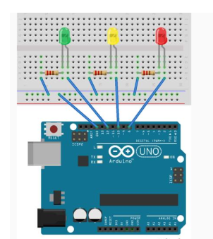

**Simulation:**

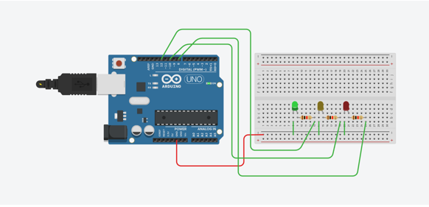

**Simulation Code:**

void setup() {  
// pin connections for the LED lights  
pinMode(8,OUTPUT);  
pinMode(10,OUTPUT);  
pinMode(12,OUTPUT);  
}  
void loop() {  
// turning on voltage at output 8(for red LED)  
digitalWrite(8,HIGH);  
delay(3000); // red LED is on  
// turning on voltage at output 8(for red LED)  
digitalWrite(10,HIGH);  
delay(1000); // yellow LED is on  
//for turning off red and yellow and turning on green  
digitalWrite(8,LOW);  
digitalWrite(10,LOW);  
digitalWrite(12,HIGH);  
delay(3000);  
digitalWrite(12,LOW); //green is off for blinking next  
//to make green on and off 3 times  
delay(500);  
digitalWrite(12,HIGH);  
delay(500);  
digitalWrite(12,LOW);

delay(500);  
digitalWrite(12,HIGH);  
delay(500);  
digitalWrite(12,LOW);  
delay(500);  
digitalWrite(12,HIGH);  
delay(500);  
digitalWrite(12,LOW);  
//to turn yellow on once  
digitalWrite(10,HIGH);  
delay(1000);  
digitalWrite(10,LOW);  
}

**Hardware Set-up:**

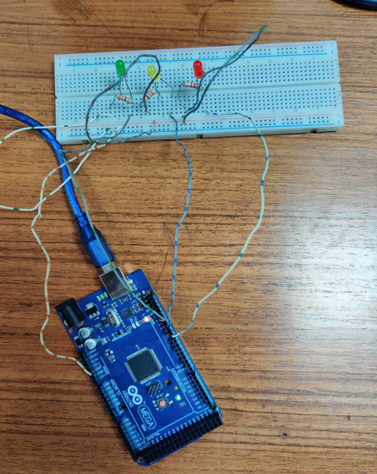

**Output Results:**

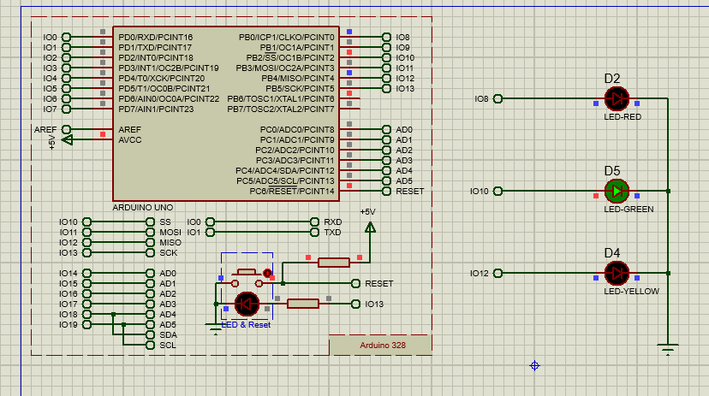

# Discussion:

# In this experiment, the traffic control system has been implemented by using Arduino Uno. First, we learned about Arduino Uno during our theory discussion and we saw it for the first time. After theory discussion, we took components of 3 LED lights RED, YELLOW, and GREEN have been taken with 3 resisters along with a breadboard. The resistors have been taken to the ground by one of the members. Then we install the IDE platform and then we start to design the circuit, and the code was implemented by another member. Codes were written with Arduino IDE where LED blink and delay functions were added to the codes. a website called tinkercad.com has been used for circuit design and simulation. A personal account had been created after a circuit has been designed. After writing the codes and simulating them, and implementing them, the code ran successfully and the result had been recorded. Thus we finished our lab experiment and returned the components

# Conclusion:

# From the experiment, we got to familiarize ourselves with the Arduino microcontroller and with Arduino IDE and for the first, we got to make codes to operate the traffic control system.

# References:

1) <https://www.arduino.cc/>.

2) <https://www.coursera.org/learn/arduino/lecture/ei4ni/1-10-first-glance-at-a-program>

3) Jeremy Blum; Exploring Arduino: Tools and Techniques for Engineering Wizardry